**MINI PROJECT-I**

**(2020-21)**

# Real-Time Web Chat App

**SYNOPSIS**



**Institute of Engineering & Technology**

**Team Members**

Harshit Verma

(181500260)

Harshita Katara

(181500263)

## Supervised By:-

**Harvinder Kaur Mam**

**Technical Trainer**

**Department of Computer Engineering & Applications**

**Introduction:**

A web chat is a system that allows users to communicate in real-time using easily accessible web interfaces. It is a type of Internet online chat distinguished by its simplicity and accessibility to users who do not wish to take the time to install and learn to use specialized chat software.This trait allows users instantaneous access and only a web browser is required to chat. Users will always get the latest version of a chat service because no software installation or updates are required.

Web chat software is sometimes used in a business context as live support software, also called live support, live help or live chat. In this case, the web chat software is integrated with a website to allow for a customer to chat with the business representative or the website owner.

**Area of Computer Science :**

**Web Technology:**

Social Networking Site

* HTML
* CSS
* JavaScript
* Node.js
* React-A JavaScript Library

**Software requirements :**

1. **Hardware:**

* Latest configuration Laptop

1. **Software:**

* Visual Studio(Version 1.38)
* Firebase (Backend)

**Problem Definition :**

This project is to create a Real-time Chat Application with firebase server and users to enable the users to chat with each other.

To develop an instant messaging solution to enable users to seamlessly communicate with each other.

**Objectives:**

The main objective of the project is to manage the details of Online Chat, Chat Application, Chat History, Chat Profile, users. The project is totally built at administrative end and thus only the administrator is guaranteed the access. The purpose of the project is to build a web application program to reduce the manual work for managing the Online chat,chat History. It tracks all the details about the Chat History, Chat profile ,users.

**Methodology:**

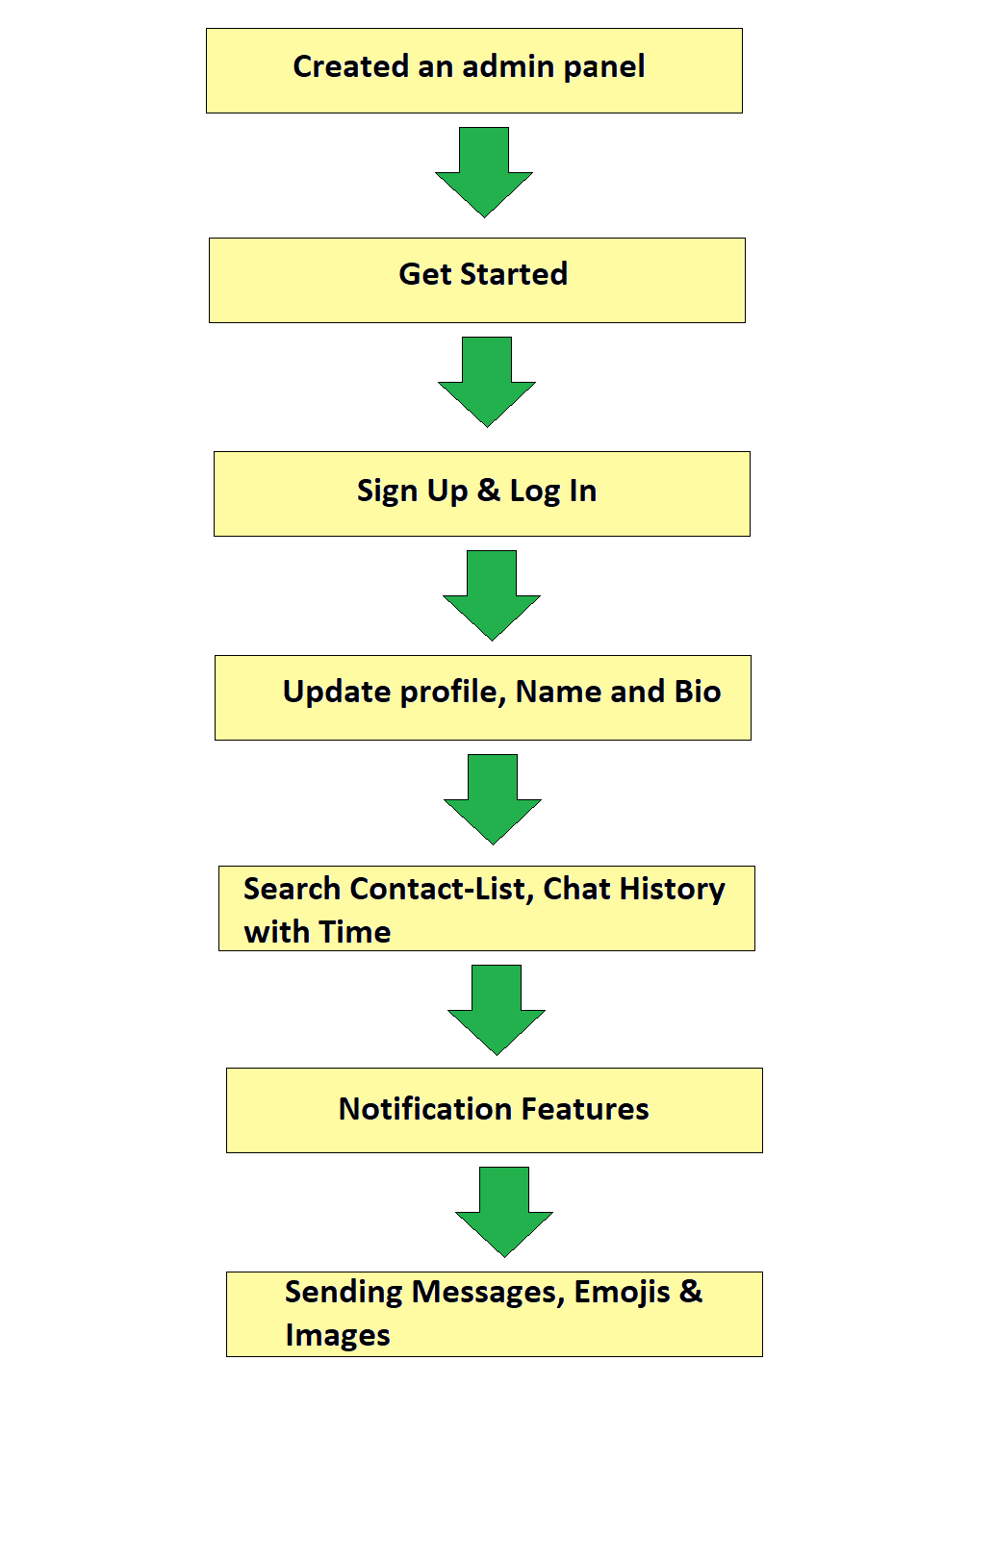

**Implementation Details:**

In this project, we have developed a react chat app using cloud firestore in the backend. To access this app users should have to first sign-up by email and password.

Users can update his/her profile by clicking on the profile icon and mentioning his/her name with bio.

So, whoever in his/her contact will be loaded and he/she can search anyone by just typing name and can see the history of their chats too and time will also display that at what time he/she has a chat with someone.

In this application, we also added a feature of message notification and feature of sending messages, emojis and images also have been implemented.

**Contribution:**

A project is successfully completed only when there is contribution from all the members of a team. In the same way to complete this project we have divided our work in an equal manner. Instead of selecting a particular task to do individually, we divided a single task in multiple subtasks so that we all can work together on the same phase or task of the project. Doing so no team member has to wait to show his or her capabilities.

**Github Link :**

Harshit Verma: <https://github.com/Harshit8126>

Harshita Katara**:** <https://github.com/HarshitaKatara>